TIMES OF INDIA-

<https://m.timesofindia.com/city/dehradun/locals-environmentalists-oppose-beautification-of-sattal-lake/articleshow/82107715.cms?utm_source=Native_Share_Tray&utm_medium=social&utm_campaign=TOIMobile>

<https://www.instagram.com/p/CNz4R8TB65G/>

HINDUSTAN TIMES-

<https://www.hindustantimes.com/environment/greenpiece-there-is-an-urgent-need-to-preserve-ecosystem-101625429963929.html>

LIVE HINDUSTAN-

<https://www.livehindustan.com/uttarakhand/haldwani/story-angry-among-bird-lovers-over-the-cutting-of-bushes-from-the-garden-of-satal-4129540.html>

HINDUSTAN TIMES-

<https://www.hindustantimes.com/cities/dehradun-news/environmentalists-bird-lovers-against-junky-tourism-in-sattal-101623013085855.html>

<https://www.instagram.com/p/CP0MEktBQk4/>

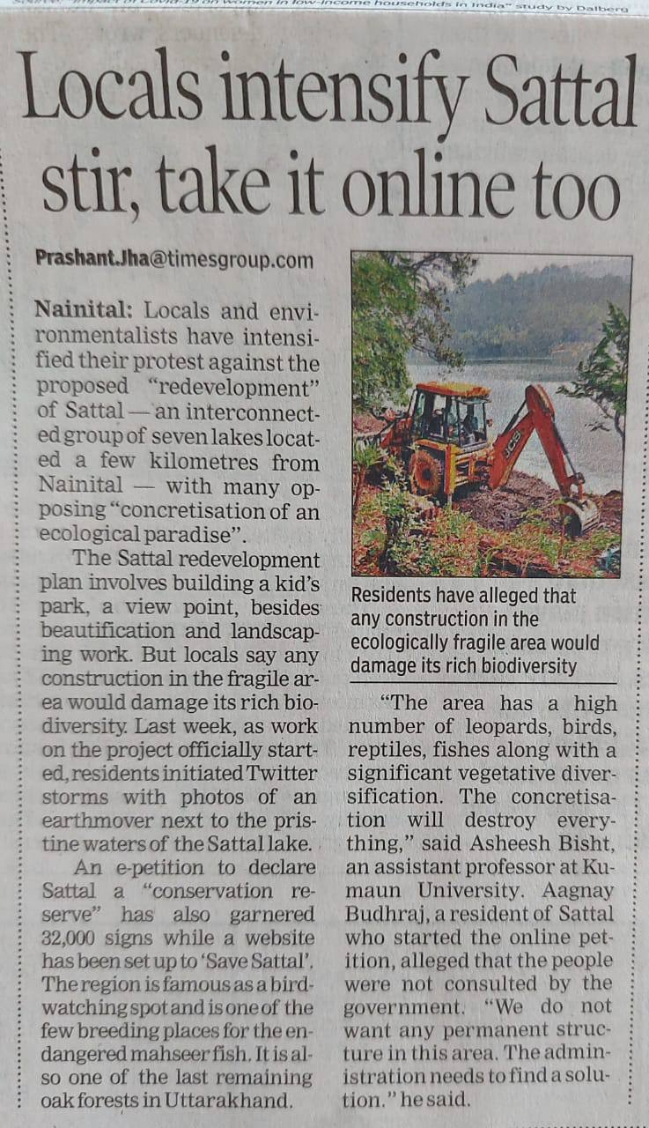 TIMES GROUP - <https://timesofindia.indiatimes.com/india/locals-intensify-sattal-stir-take-it-online-too/articleshow/84160726.cms>

SAHARA GROUP- <https://www.instagram.com/p/CQpqJ--Buzq/>

DOWN TO EARTH- <https://www.downtoearth.org.in/blog/environment/save-sattal-tomorrow-will-be-too-late-we-must-start-change-today-77801>

TIMES OF INDIA- <https://timesofindia.indiatimes.com/city/dehradun/Armed-with-online-petition-website-Twitterstorms-locals-intensify-stir-against-Sattal-development/articleshow/84151294.cms>

HINDUSTAN TIMES-

<https://twitter.com/htTweets/status/1402185730839904258?s=19>

HINDUSTAN -

<https://www.livehindustan.com/uttarakhand/haldwani/story-angry-among-bird-lovers-over-the-cutting-of-bushes-from-the-garden-of-satal-4129540.html>

AMAR UJALA - <https://www.amarujala.com/uttarakhand/nainital/now-the-tourists-will-be-able-to-see-water-fall-in-sattal-bhimtal-news-hld4069139113>

<https://www.amarujala.com/uttarakhand/nainital/surat-of-satatal-will-be-renovated-with-six-crores-nainital-news-hld417173374>

<https://www.amarujala.com/amp/uttarakhand/nainital/indoor-foreign-bird-attracts-bird-watchers-the-birds-tweet-here-satnal-near-nainital-chandi-and-pangoot-have-a-unique-world-of-birds-nainital-news-hld403715689>

<https://www.amarujala.com/uttarakhand/nainital/41544645199-nainital-news>

<https://www.amarujala.com/uttarakhand/nainital/121522957591-nainital-news>